
1.Install Java
- requirement : Java 6 Update 45

2.Install Eclipse
- requirement : Helios

3.Protege4.1 Source

4.Run Protégé 4.1 in Eclipse
1). Double click Eclipse 
- Run and choose workspace as protégé folder

2). Import Protégé

- [File] ➔ [Import]

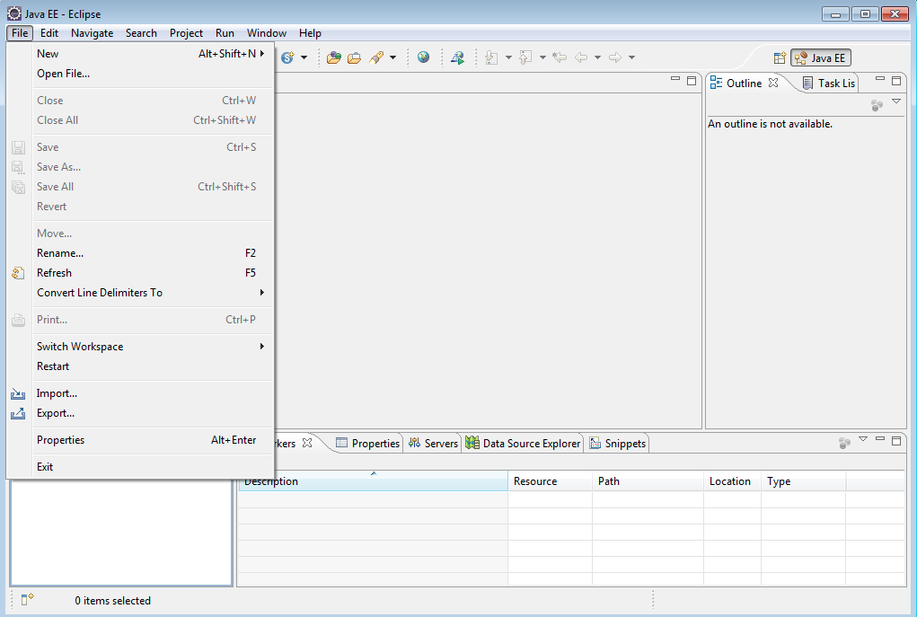

- [General] ➔ [Existing Projects into Workspace]

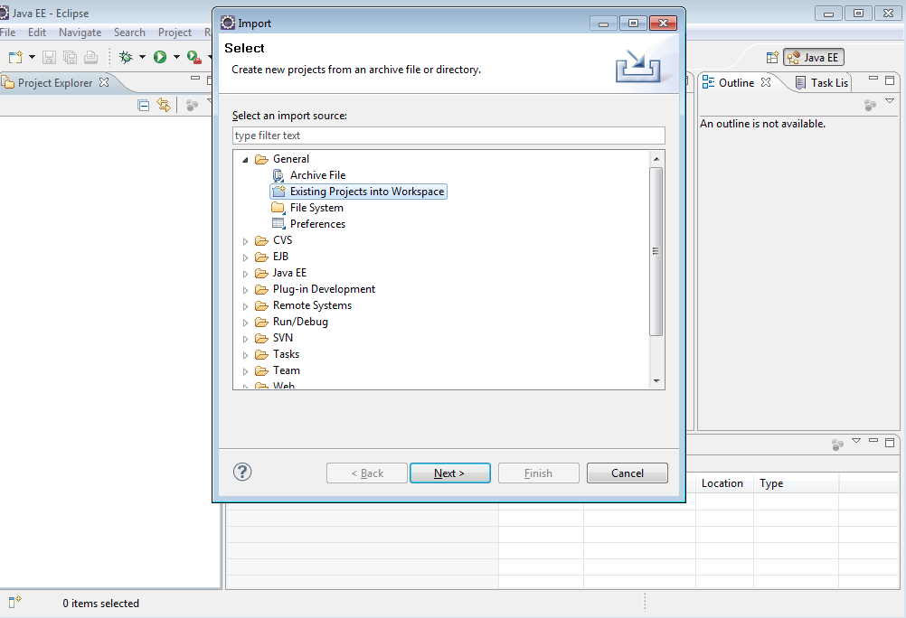

- [Select root directory] and select all projects.
- Check [Copy projects into workspace] and click [Finish].

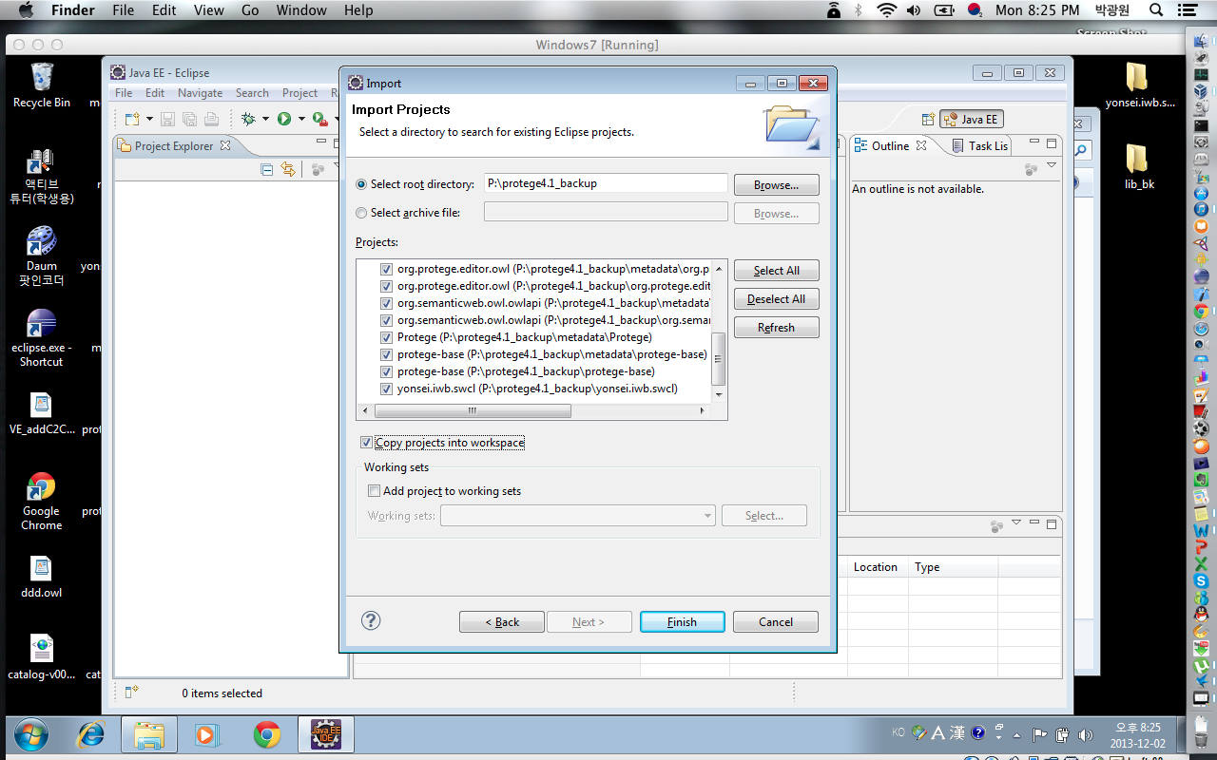

- Click and click [Protégé]

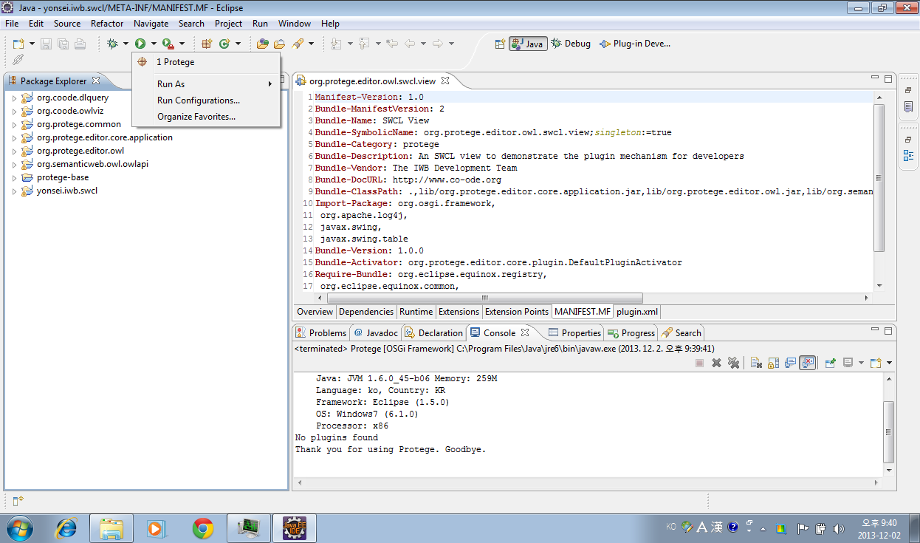

- Choose ontology which will be used in Semantic Web Constraint Language (SWCL).

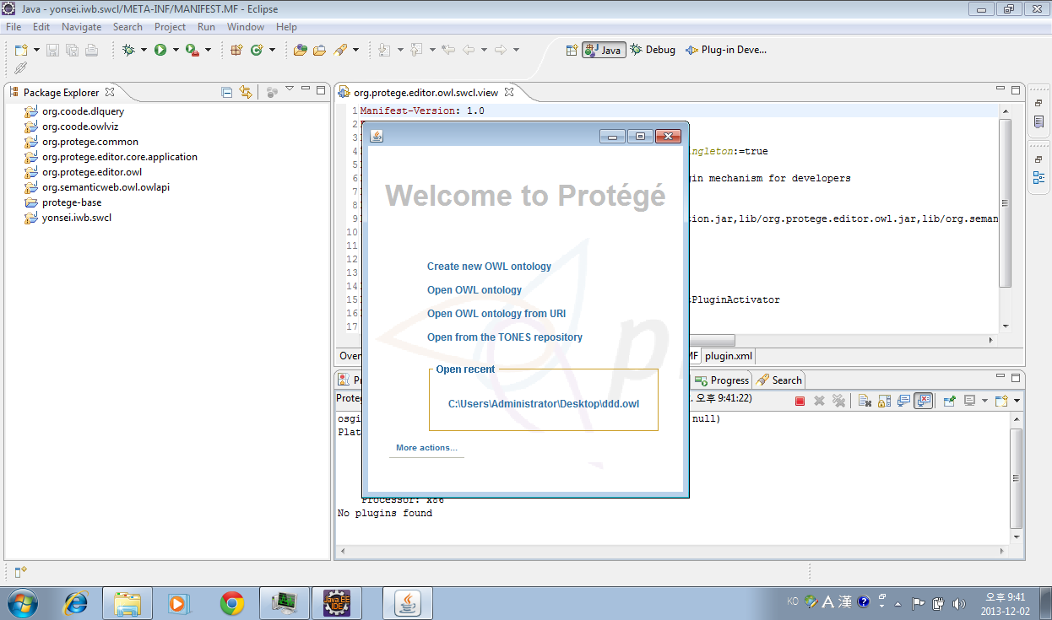

- [Windows] ➔ [Views] ➔ [Ontology views] ➔ Choose [SWCL View]

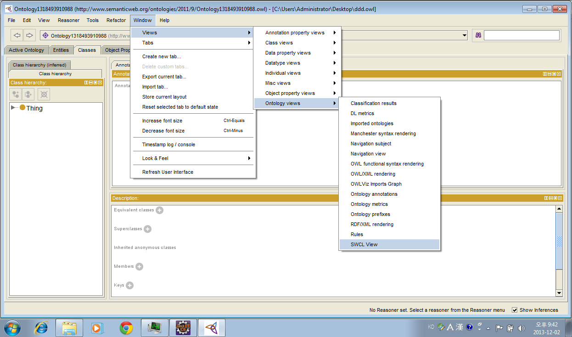

- In [SWCL View], create and edit Constraint in your needs.

